Report 4: evolutionary design

1) Authors:

- Sofya Aksenyuk, 150284;

-Uladzimir Ivashka, 150281;

-Piotr Górecki, 148282;

2) In the experiment, the evolutionary goal was jumping creatures that fast on land.

3) The Framscript:

Simulator.init();

Simulator.start();

var pusus = File.create("_logs.txt");

var out = "";

Simulator.print(pusus);

var startTime = Math.time;

var ini = 0;

var count = 0;

while (count<1000)

{

Simulator.step();

if(ini<stats.st_max_fit)

{

out += stats.st_max_fit;

out += "\n";

ini = stats.st_max_fit;

count ++;

}

}

out += Math.time - startTime;

pusus.writeString(out);

pusus.close();

4) A list of modified values of the parameters and the script fragments in Mechastick:

-Parameter 1:

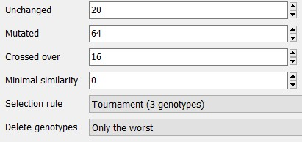

Fitness: return 0.0+this.velocity*1.0+this.numneurons*7.0+this.distance*10.0;

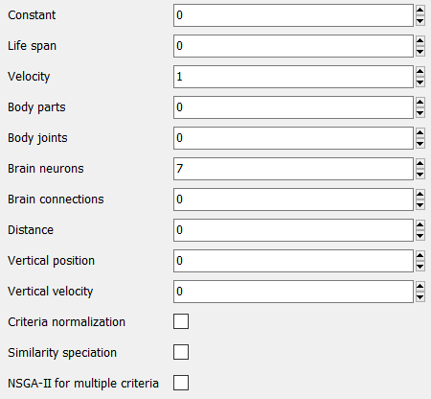

-Parameter 2:

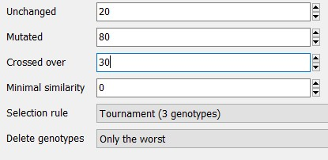

Fitness: return 0.0+this.velocity*1.0+this.numneurons*7.0+this.distance*10.0;



5) Results of evolution over 10 runs of 10.000 evaluations:

-Parameter 1:

The best genotype: M**X(X**[**|** 0 **:**-0.9**,G:**0]**,**rrLL**X**[**G:**-1.404]M**X**[**|** 0**:**0.8**,**-1**:**2.9]**)**

-Parameter 2:

The best genotype: **(**Mii**X**[**N,** 9**:**-0.204**,**5**:**1][**\***][**\***]**,** i**X**[**N,** 6**:**0.871][**@,** -2**:**-0.613]L**X**[**T**][**T**][**|,** -5**:**-0.688**,** **p:**0.25]L**X**[**N,** 1**:**-4.672**,** 0**:**-1.513**,** -6**:**-1][**G**][**|,** -8**:**6.584][**G**]**X**[**Gpart**][**|,** **r:**0.872**,** -7**:**1]**)**

6) -Plot for fitness comparison:

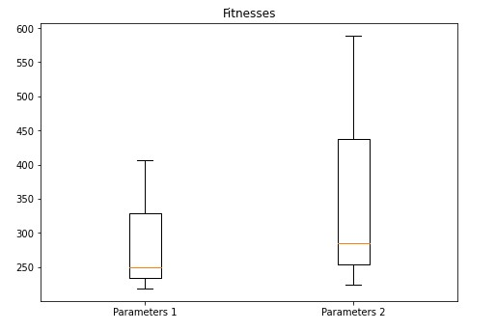

-Plot for time comparison:

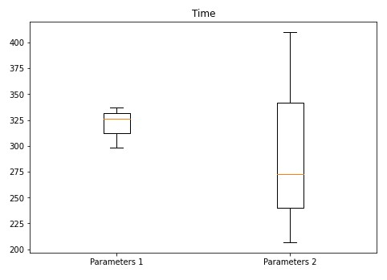

7) Fitness plot separately for each evolutionary run:

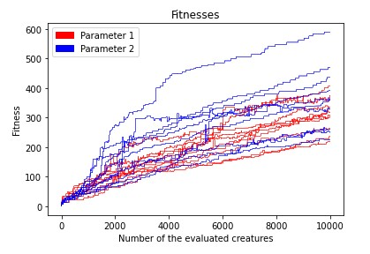

8) Quantitative conclusions (based on the bar plots and fitness-in-time plots):

-Based on the fitness plot, it can be clearly seen that the best (i.e. the highest) fitness is reached using Parameter 2 combination of parameters, where the probability of mutation and cross-over is higher than in Parameter 1. Nevertheless, the average fitness values of both sets of parameters are almost the same.

-Based on the time plot, the average time-spending is smaller than in Parameter 1 case, despite the fact that the maximum value belongs to Parameter 2. Apart from that, it can be noticed that the range of Parameter 2 results is much greater than in Parameter 1 case. It can be explained by the fact that in the second case the probability of mutation and cross-over is increased.

9) The behavior of the best creatures is as it was expected: they start jumping longer that increases their speed. Such improvements are caused by the changes in their genotypes: creatures get more neuron connections during evolutionary process that is the main cause of such progress.

Making comparison between the best creatures of two parameter sets, the genotype of Parameter 2 framstick is much more complicated and well-structured than Parameter 1 one.

Youtube video: <https://youtu.be/ZgpQ09tv478>